***Blood Faith XVIII***

My dearest Porfirio,

I grow weary of your absence despite the light of Christ that fills me and sustains me. Now that you consider me a Lapsi, I understand that the differences between us are too great. How many lovers have said *that* through the centuries, but none so truthfully as I do now! I shall never see you again because of it (and for another reason which I will explain later). But my heart still aches. In fact, because I am no longer a Chosen, it aches more than it ever could have before. (Though, on the other hand, drinking the blood of the immortal God during the Eucharist has been infinitely more satisfying than drinking the blood of a *Homo mortalis* ever was.)

And that brings me to the real point of this letter (which, in deference to your wishes, will be the last). In the early days of my newfound innocence—and before you repulsed me—we discussed several scenarios to explain the unexpected (and glorious) outcome of my christening. We supposed that the Shedding severed our link to Original Sin or that it transferred our ancestry from Ḥavvah to Lilliṯ and that the sacrament of baptism acted to reverse those effects. Or we considered whether my new faith protected me while the Holy Water burned away the evidences of my former Shedding. But as I have studied my apocatastasis over these few months since you left, I have come to another conclusion.

I lost my immortality simply because I stopped believing in it. The Blood have long promulgated the idea that the faith of the *Homo mortalis* was sufficient to endue an artifact with power. Indeed you learned as much in the catechisms of your *paṇḍitá*, Hæmming. But I now believe that faith on the part of the Blood is just as important. If you did not believe in the power of garlic, iron stakes, crucifixes, etc., *just as strongly as did the wielder*, they would have no effect on you.

This may be the key to defeat the Council. They have jealously guarded the secret of Amaymon’s perdurance in the tetrix. Besides themselves only a handful of others have learned of the tetrix’s existence: Hæmming, you, Pereles, and me. Thus it is only the combined faith of the Council that maintains the tetrix as an artifact and its ability to house the soul of Amaymon. It is also their collective faith—and nothing more—that convinces them that the ritual they are surely devising for the Reclamation will work. I have already despatched a spurious letter that is certain to be intercepted by the Council. It contains disinformation about one of the magic circles they intend to use (as well as misleading them about your current whereabouts). I pray that it may cause their faith to falter long enough for you to reach them before they attempt the Reclamation.

My seclusion, suddenly imposed on me by your unannounced departure, has driven me to the hidden library you discovered under the Shah-i-Zinda. I have spent my time researching the original thirteen Hunters who went after Amaymon. We know from the scrap of paper you found in the *Book of Abramelin* that Ishpaki, Palakus, and Aristotélēs lost their lives in this endeavor. Lucretius, Thielvar, and Shenouda (and until recently Sembecconi) are members of the Council, which means they were seduced by Amaymon. Of the remainder, I believe that Rhydderch, Iltiŕbaś, and Skomantas perished in the first confrontation with Amaymon and that Thrax, Tarquin, and Oeagrus lost their lives during the crossing of the Gedrosía Desert. They have been replaced by the remainder of the current members of the Council:

**Councilman *Sēdēs Niger***

Terv replaced Rhydderch Black See of Antiócheia

Mielitoivo replaced Iltiŕbaś Black See of Syracusæ

Decaeneus replaced Thrax Black See of Ninua

Girolamo replaced Tarquin Black See of Rōma

Harfidel replaced Ishpaki Black See of Ephesos

Bardyllis replaced Skomantas Black See of Sfard

Endubis replaced Palakus Black See of al-Iskandariyya

Anacreon replaced Oeagrus Black See of Thessaloniki

Maritiwijo replaced Aristotélēs Black See of Kórinthos

Also, as I hinted above, I have received word that as a result of our activities related to the *Book of Abramelin*, Sembecconi was tried and executed for treason. A Merovingian, Chlodomer, has replaced him as the Black See of Yerûšalayim.

Your task (which is a daunting one) is then to destroy the Council. Once they are all deceased there will be no one left to maintain the tetrix by their faith. Thereafter, should anyone chance to discover it, they will not know its purpose *and so cannot restore its function by their faith*. *In summarium*, to prevent the return of Mégas Aléxandros you merely need to kill the thirteen members of the Council and Hæmming. I tentatively suggest a way:

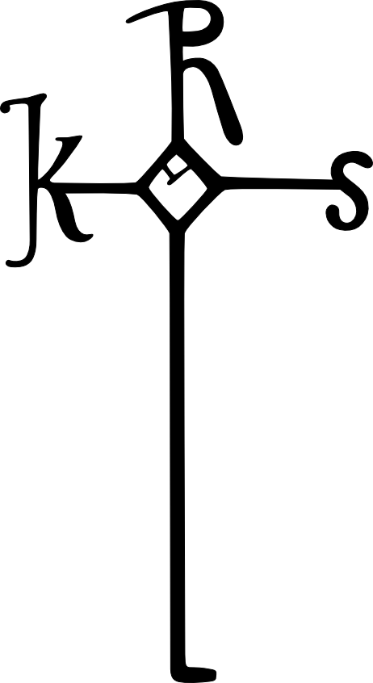

*In hoc signo vences*

There is one more thing that I must address: the other three of us who have knowledge of the tetrix. News has reached my ears of Pereles’ extermination at the hands of Gaius Messōrius Vēnātor, but you and I live on. To ensure this plan works, you and I must perish that there might be unbelief. For my part the passage into death will be hastened. As a result of my baptism erasing the effects of my Shedding, my hundreds of years of illicit life have suddenly returned and wear at my now-susceptible body in a rapid and relentless fashion. By the time you receive this *billet-doux-amer* I expect to have returned to the dust of *ʿEḏen*.

That leaves you, Porfirio. I do not know how a Blood can take his own life, but you must find a way or all we’ve worked for will be for naught. Because you have rejected the salvation of baptism (and because you will be inflicting self-destruction), you will be consigning yourself to eternal suffering in the abysms of *Tártaros*. But I hope for the sake of all living that you find the will to do so.

Farewell forever, my love,

Sibyl